*Logic Specification Template*

|  |  |  |  |
| --- | --- | --- | --- |
| **Student** | Roberto Cantu Reyes | **Program #** | 5 |

|  |  |
| --- | --- |
| **Class Name** | PrintResults |

|  |  |
| --- | --- |
| **Method Name** | print |

|  |  |
| --- | --- |
| **Parameters** | none |
| **Pseudocode:** |

|  |  |
| --- | --- |
| **Class Name** | Main |

|  |  |
| --- | --- |
| **Method Name** | main |

|  |  |
| --- | --- |
| **Parameters** | none |

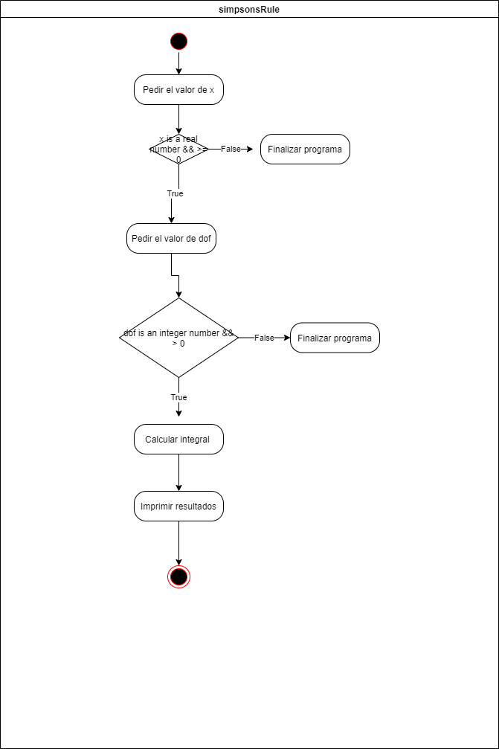

|  |  |
| --- | --- |
| **Class Name** | StatisticalAnalysis |

|  |  |
| --- | --- |
| **Method Name** | gamma |

|  |  |
| --- | --- |
| **Parameters** | Double num |

}

|  |  |
| --- | --- |
| **Class Name** | StatisticalAnalysis |

|  |  |
| --- | --- |
| **Method Name** | tDistribution |

|  |  |
| --- | --- |
| **Parameters** | Double x , int dof |
|  |

|  |  |
| --- | --- |
| **Class Name** | StatisticalAnalysis |

|  |  |
| --- | --- |
| **Method Name** | simpsonsRule |

|  |  |
| --- | --- |
| **Parameters** | Double x , int dof |

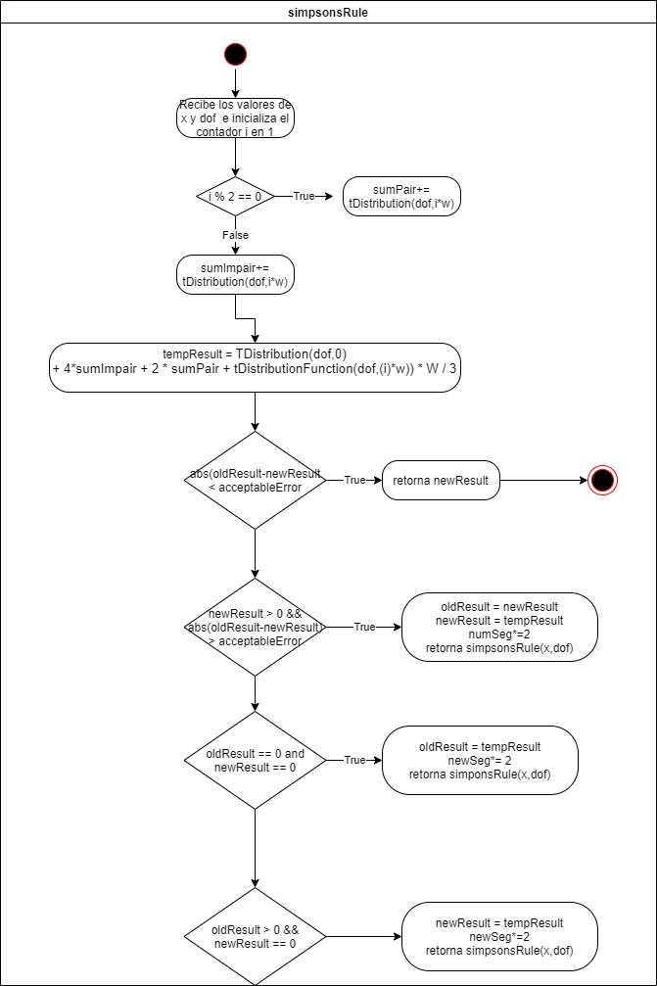

|  |  |
| --- | --- |
| **Class Name** | CalculateX |

|  |  |
| --- | --- |
| **Method Name** | calcX |

|  |  |
| --- | --- |
| **Parameters** | Double x |

